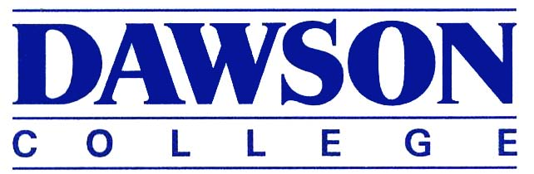

**Physics**

**Science Program**

**Waves, Optics and Modern Physics**

**203-NYC-05 [ADD YOUR SECTION NUMBER], Winter 2020**

## Modified Evaluation Scheme Common To All Sections (Updated April 15 2020):

This course is now evaluated on a "pass" or "fail" basis, where

* "pass" means you obtain an "equivalence" (EQ) for the course,
* "fail" means you are given an "incomplete" (IN) that will disappear from your transcript when you re-take the course.

Either way, this course will not contribute to your R-score.

**Grading scheme:** Laboratory work 20%

Assignments and/or quizzes 20%

Tests 60%

There will not be a final exam.

**In order to obtain a "pass"**, students must satisfy both of these criteria:

* attain a final grade of at least 60%, calculated according to the evaluation scheme above, **AND**
* obtain a grade of 40% or more in all tests done after April 15.

## Instructor: [Name]

## Contact Information:

*[Office number]*

*[Email address]*

*[Phone ]*

*[Preferred contact method and standard response time]*

## Office Hours:

## *[Cont’ed teachers are not required to have office hours]*

## Detailed Evaluation Scheme (Updated April 15 2020):

Laboratory work 20%

Assignments [ ]%

Quizzes [ ]%

Tests 60%

## Class Tests Schedule:

**Assignments:**